41.39: 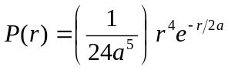
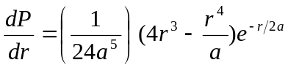

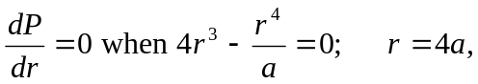
In the Bohr model,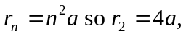which agrees.

